KINGSDALE AND PERRY PARK SURGERY



Health and

Care Passport

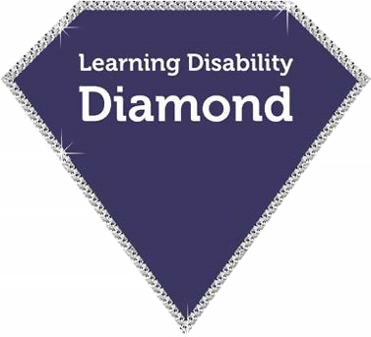

**Standards**

**Name:**

**Contents**

|  |  |
| --- | --- |
| **My Details** | **3** |
|  |  |
| **Communication** | **4** |
|  |  |
| **Home Environment** | **5** |
|  |  |
| **Living Support** | **6** |
|  |  |
| **Supporting pain or distress**  **in Hospital** | **10** |
|  |  |
| **Sight and Hearing** | **13** |
|  |  |
| **Food and Drink** | **14** |
|  |  |
| **Keeping Safe** | **15** |

**My Details**

This Health and Care Passport should be completed by you and the people that know you best. By filling it in, you are giving permission for your information to be shared with health and care staff who are caring for you. This is called consent.

**My name is...**

**I like to be called...**

**My pronouns are:**

**they/them**

**she/her**

**he/his**

**NHS number...**

**Date of birth...**

**Address...**

**Mobile number...**

**Landline number...**

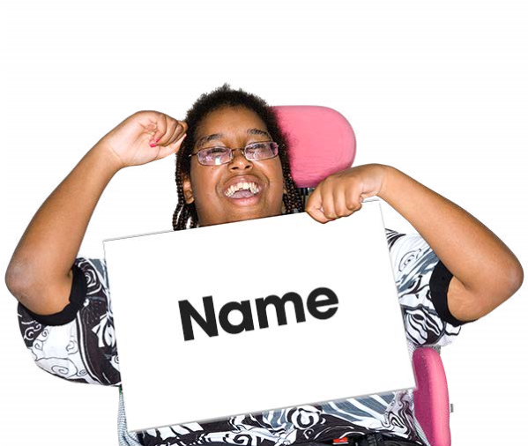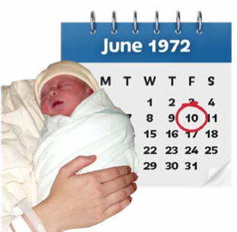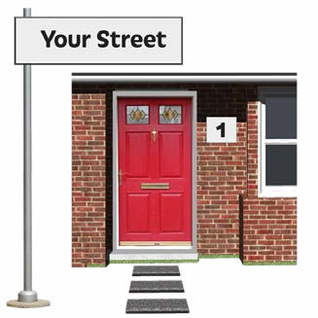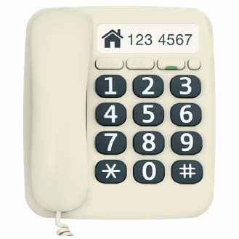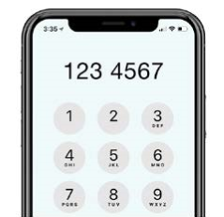

**Tick yes if you agree to this.**

**To those people providing care to me:** This health care passport has information about me, to help you support and care for me.

You can get more information about my medical records through the Health Information Exchange.

**Communication**

**How well do I know and**

**understand speech...**

**What languages I speak...**

**Communication aids or tools I use...**

**The best way to give me information is:**

**e.g. easy read, with carer etc.**

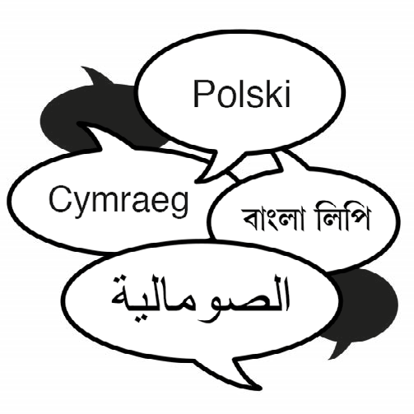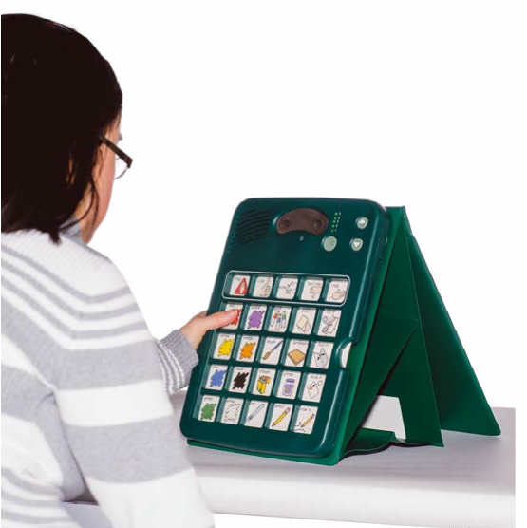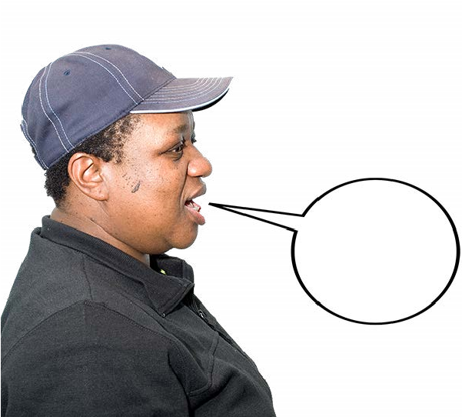

**Home Environment**

**Where I live:**

**Live independently**

**Supported living**

**Shared house**

**Live with family**

**Live with 24 hour support**

**Daily / weekly hours of support**

**I have support:**

**Every day of the we**

**ek**

**1 day a week**

**2 days a week**

**3 days a week**

**4 day a week**

**5 days a week**

**6 days a week**

**How many hours supp**

**ort a week do I**

**have...**

**Who do I normally live with...**

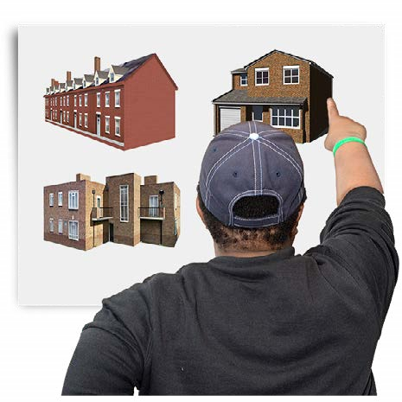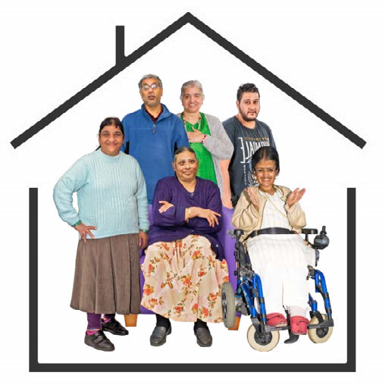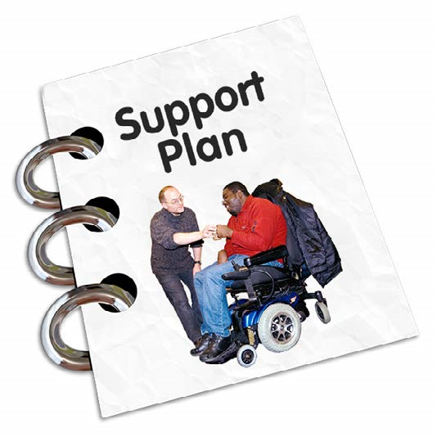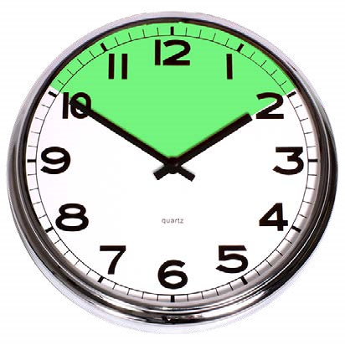

**I don’t have support**

**I don’t know**

**I need help to dress**

**What help do I normally need...**

**I need help to wash**

**What help do I normally need...**

**I need help to brush my teeth**

**What help do I normally need...**

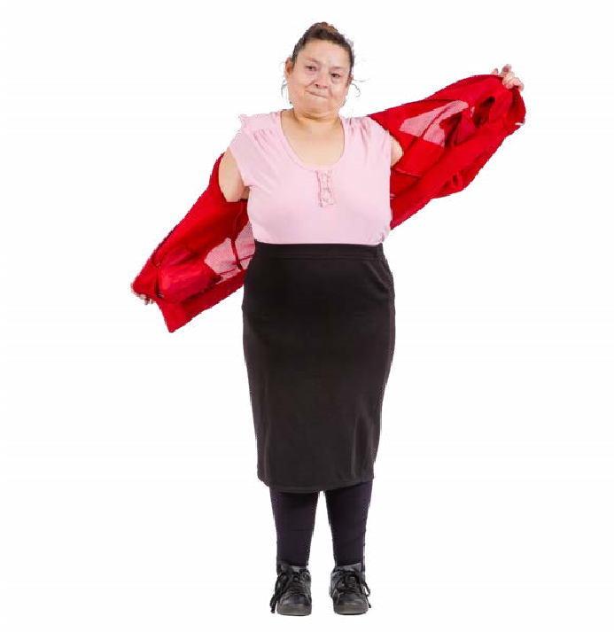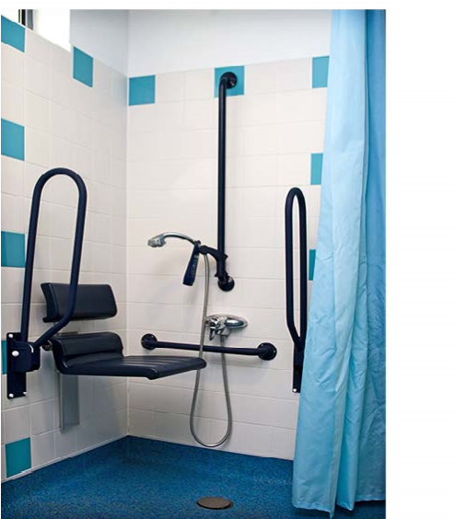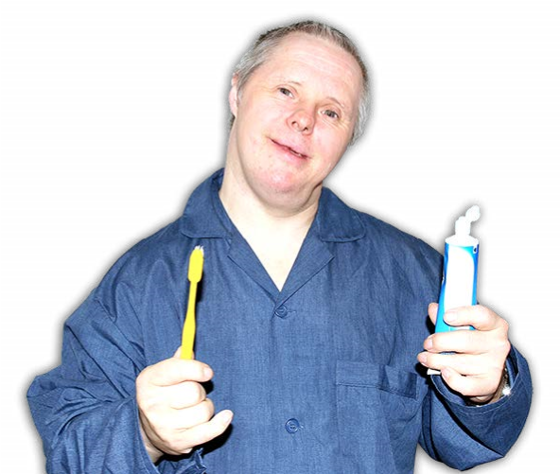

**I need help to toilet**

**What help do I normally need...**

**I use continence aids**

**What I use..**

**Normally I poo…**

**at least once a day**

**at least once every 2 days**

**at least once every 3 days**

**at least once a week**

**unsure**

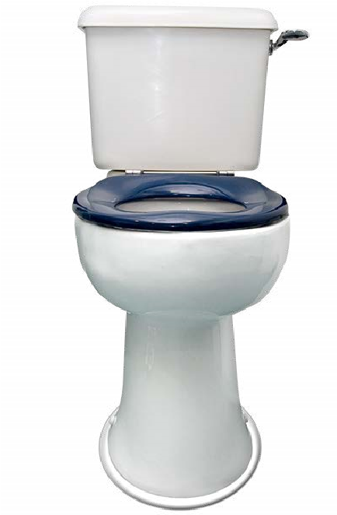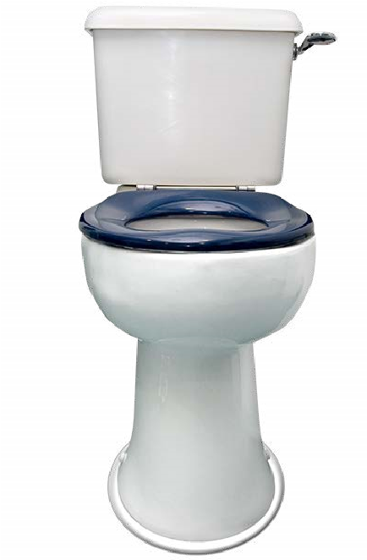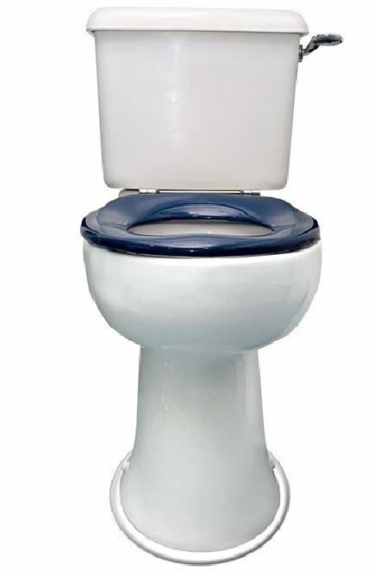

|  |
| --- |
| **I need help choosing my food and drink What help do I normally need...** |
| **I need help to eat**  **What help do I normally need...**      **My food should be:**    **Cut up**      **Pureed** |
| **I need help to drink**  **What help do I normally need...**      **My drink should be:**  **Given in small amounts**  **Given using a specific type of cup**  **Thickened** |

**I need help with my posture**

**when sitting / lying**

**What help do I normally need...**

**I need help to get about**

**What help do I normally need...**

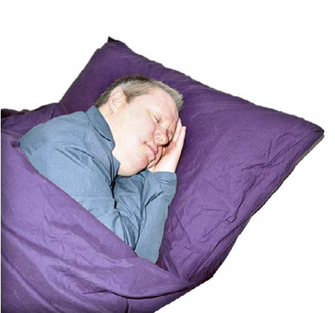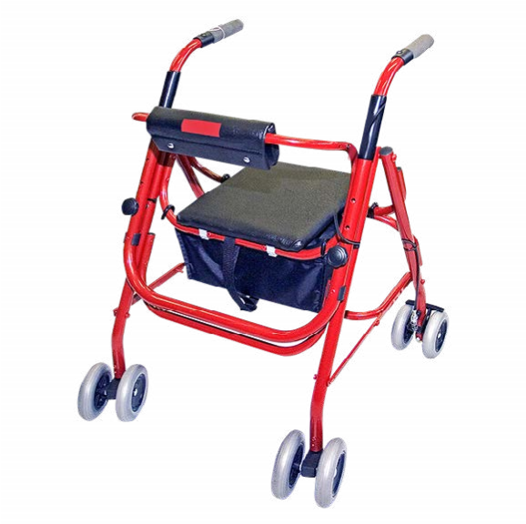

**Supporting pain or distress in Hospital**

|  |
| --- |
| **How do you know I am in pain...**    **How to support me if I’m in pain...** |
| **Different ways I communicate when I am distressed...** |

**Supporting pain or distress in Hospital**

|  |
| --- |
| **Things that are likely to cause me distress (triggers)...** |
| **Things you can do to help me not become distressed...** |
| **Things that you can do to support me when I have already become distressed....** |
| **Normally...**  **I sleep a lot**  **I am usually very quiet**  **I am very chatty** |

**Support in Hospital**

|  |
| --- |
| **If I am staying in hospital who needs to stay and how often..**  **What to do to help me in places that are strange for me...** |
| **How to support me to be happy...** |
| **When I’m happy I will...** |
| **How to support me to keep calm and happy (consider pain relief)...** |
| **How I take medicine:**  **You can tick more than one box...**  **whole tabletinjection crushed tablet syrup other** |

**Sight and Hearing**

|  |
| --- |
| **Seeing (problems with sight):**  **I have problems with my sight**  **I wear glasses**  **I have poor sight**  **I am partially sighted or registered blind**  **More information on my sight...** |
| **Hearing (problems with hearing):**  **I have problems with my hearing**  **I wear a hearing aid**  **I lip read**  **More information about my hearing...** |

**Food and Drink**

|  |
| --- |
| **Food and Drink:**  **I eat all foodI am dairy free**  **I am vegetarianI have food allergies**  **I am veganI eat Halal food**  **I am gluten free**    **My food allergies are...**  **Other food concerns...** |
| **I am at risk of choking...**  **Yes**  **No**  **Additional information...** |

**Keeping Safe**

|  |
| --- |
| **How I keep safe... e.g. bed rails, support with challenging behaviour, do I wander, do I fall** |
| **Sleeping, my normal sleep patterns and routine are...** |
| **Things I like, please do this...** |
| **Things I don’t like, please don’t do this...** |

|  |
| --- |
| **3 things that will make my stay in hospital better...** |
| **Is there any other information we should know whilst you are in hospital...** |
| **Have you had help to complete this Health and Care**   |  | | --- | |  |   **Passport? Tick yes or no.**  **If yes who has helped you?** |

**Keeping Safe**